Step 1: - Run the below command to check the object of QZHBCGI is present in QHTTPSVR or not.

**wrkobj Qhttpsvr/Qzhbcgi**

Step 2: - After getting the QZHBCGI object, Check the service program of QHTTPSVR and see the Procedure which we are going to use to communicate our IBM I to Web browser.

**dspsrvpgm Qhttpsvr/Qzhbcgi**

**Below is the highlighted Procedure which we are going to use.**

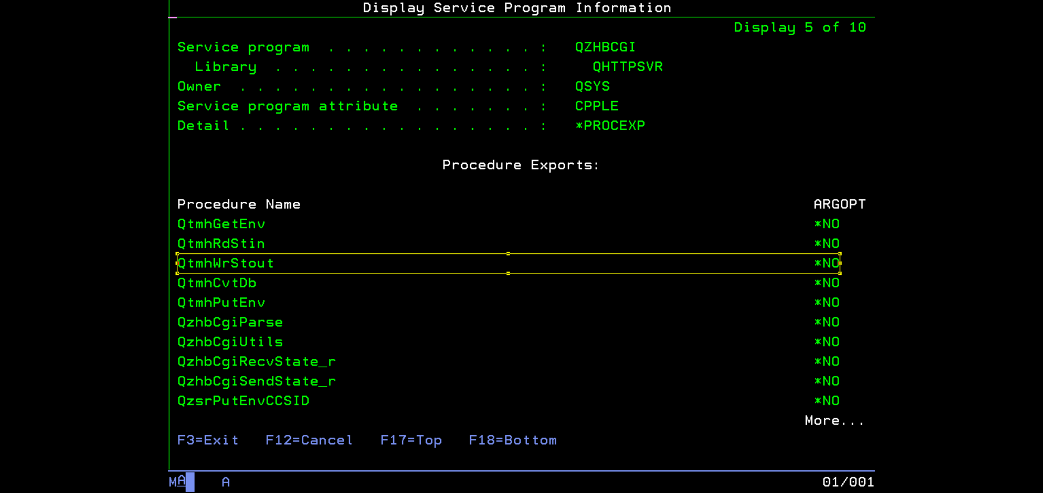

Step 3: - Create RPGLE program with above procedure. You can take references from the code shared with name RPG01.

Step 4: - Compile the program with module and bind your program with the service of QHTTPSVR/QZHBCGI

Step 5:- Finally enter your As400 Ip/lib name/program in the URL and Message will be displayed as shown below.

